**1 Add a category(TASK 1)**

**Request Type :**POST

**Request URL :** localhost:3000/addCategory

**Sample Req object :**

1. **To add a category**

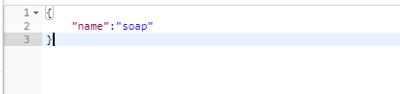

1. **To add a category and a subcategory**

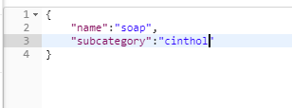

1. **To add one more subcategory to already added parent category**

Parent category is already added before and below we are adding outdoor

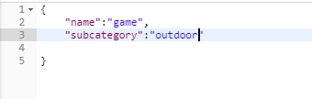

**2 Add a child category (TASK 1)**

**Prerequisite:** parent category should already be added before hand only

**Request Type :**POST

**Request URL :** localhost:3000/addCategory

**Sample Req object :**

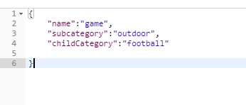

**3 Add a product mapped to one or multiple categories (TASK 2)**

**Request Type :**POST

**Request URL :** localhost:3000/addProduct

**Sample Req object :**

**To map 1 category**

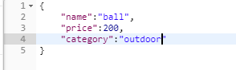

**To map more than 1 category**

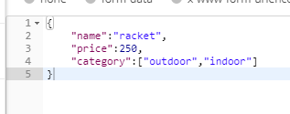

**4 get all product by a category (TASK 4)**

**Request Type :**GET

**Request URL :** localhost:3000/categoryData

**Req object**

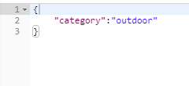

**5 Update details of a product (TASK 5)**

For doing the update we need to get the specific product id from db to get the id

Visit page from browser **localhost:3000/getProductDetails** and cope the id of the product you want to update

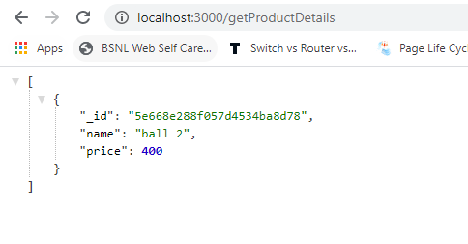

After getting the id make a request

**Request Type :**GET

**Request URL :** localhost:3000/updateProduct

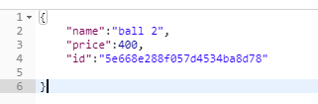

**Name and price contains the new name and price of the product who’s id you have provided here.(you can give only 1 value as well name/price)**

**6 To get the details of all category and its sub category.(TASK 3)**

**Visit url** <http://localhost:3000/>